Bulk purchase access codes
When someone does a bulk purchase, they get an access code for that purchase which they can give to others. Then the access code can be redeemed via the Catalog by either clicking the link that was sent via the canned message or by going to the course in the Catalog and clicking "or enter an access code".

When purchasing the course enter the quantity and click the "For someone else" checkbox.
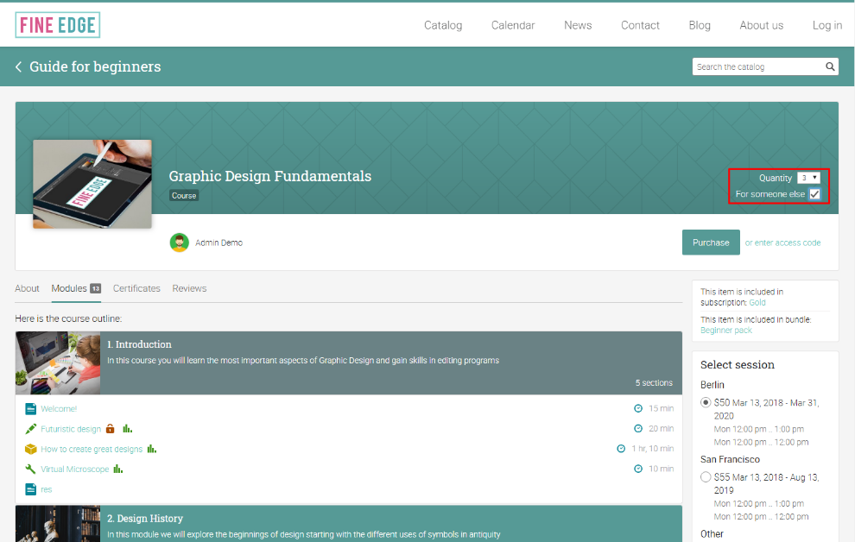
When you complete the checkout process, in the Purchases area of your dashboard the access code is shown next to the bulk purchase.
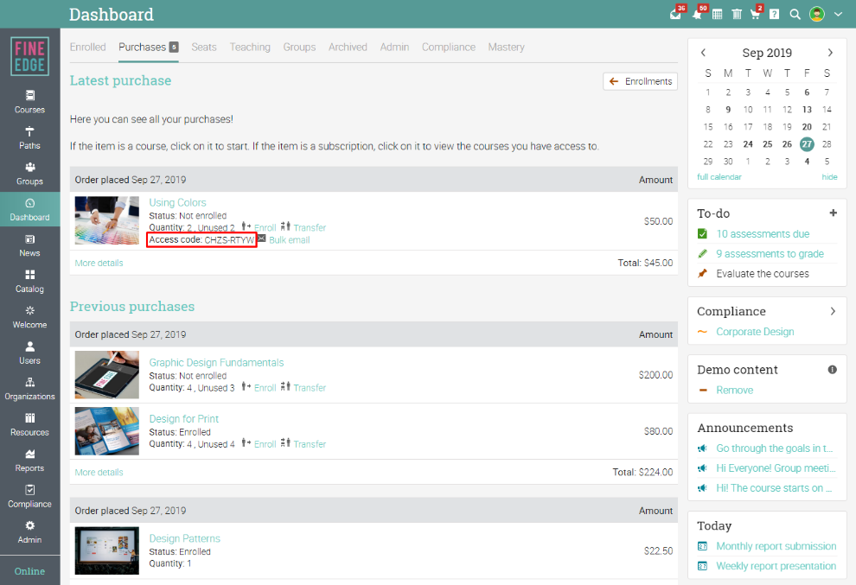
If you want to send the access code via email, click on "Bulk email".
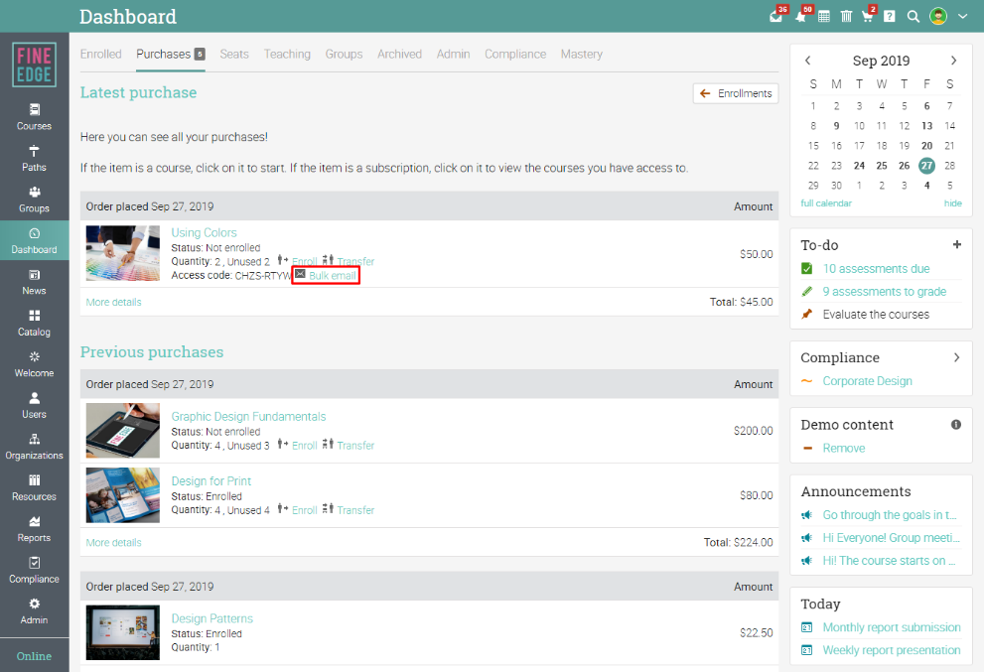
A pop-up will open that allows you to enter the email addresses of the people you'd like to send the access code to. The email is initialized from a canned message. You can also click "Send using your own email client" if you prefer to send it from your own email client.
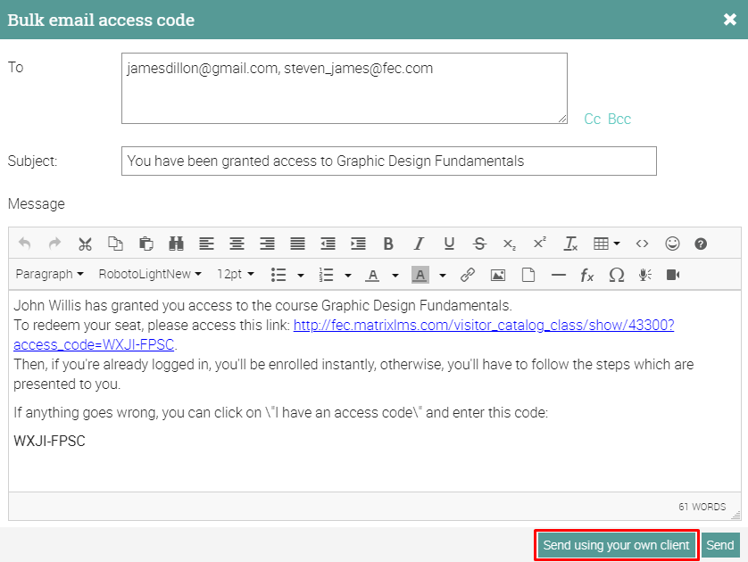
When someone receives the email, they can access the Course catalog by clicking the link in the message.
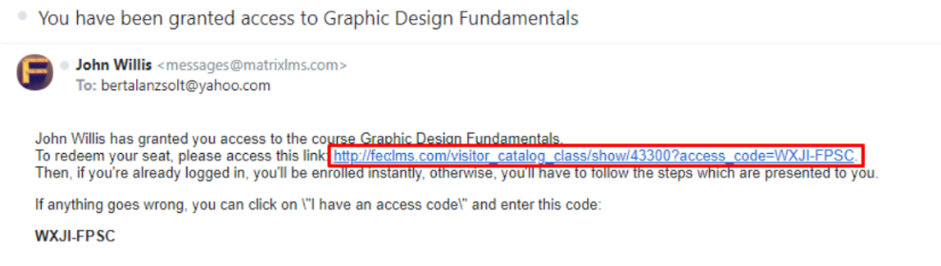
They will be redirected to the course's catalog page and the access code will be automatically entered. A pop-up will open where visitors can select to create an account or in case they already have an account, they can sign in.
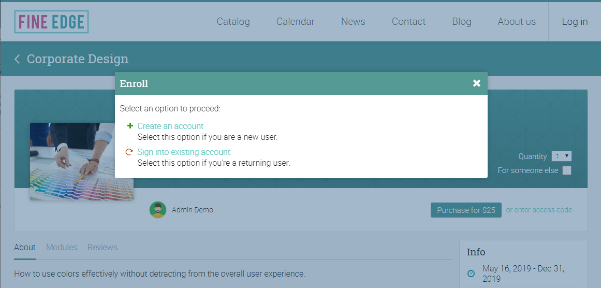
Alternatively, visitors can click the "or enter an access code" link on the course's catalog page, under Purchase and enter the access code manually.
