If You Mean to Enroll Others in any of our programs (and not yourself), but you find you have enrolled yourself, you can
Transfer your enrollment to someone else.
First, open the program. At the right top of your screen, see your picture (or icon if no picture). Click there and then click on purchases. Scroll down to the bottom of the page. Click on ‘seats’.
- Transfer your enrollment to another person. To do that, you first register the person on the site. Then, using the Transfer button you see under your purchases, go through the steps on the next screen to transfer your registration to the other person.
Enrolling Others
You will see the number of seats you have purchased, and the number you have used. The simplest way to assign someone a ‘seat’ is to use the ‘bulk email’ that you see when you click on ‘seats’.
Finding your access codes
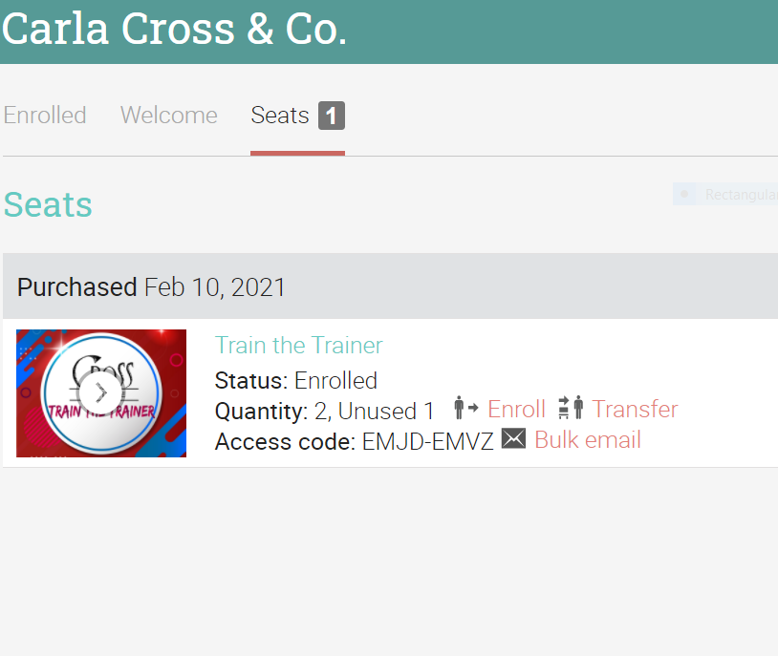
You can always click on Purchases/Details (at the bottom of the page). This will show the number of purchases and your access code. You can also see your access code on the last line of Seats purchased (see screen below)..

